Difference b/w ***Git , GitHub*** and ***GitBash***

* Git :-

Git is a version control system used by developers to manage and track changes in code. Think of it as a save system for your projects that allows you to:

* Save versions (called commits) of your work .
* Go back to previous versions .
* Collaborate with others without overwriting each other's work .
* GitHub :-

**GitHub** is a **cloud-based platform** where you can **store, share, and collaborate on code** using **Git**.

Think of GitHub as:

**A social network + storage space for code that uses Git under the hood.**

* GitBash :-

Git Bash is a command-line tool for Windows that lets you use Git and Linux/Unix commands (like ls, pwd, cat, etc.) on your computer.

Git Commands

1. git --version : Knowing the version of the Git
2. git init : initializes new git repo in your current directory



1. git add filename.txt : stages changes on single file named filename.txt



or

git add . : stages all changes in the current folder

1. git commit -m “first commit” : creates a new commit with message “first commit”

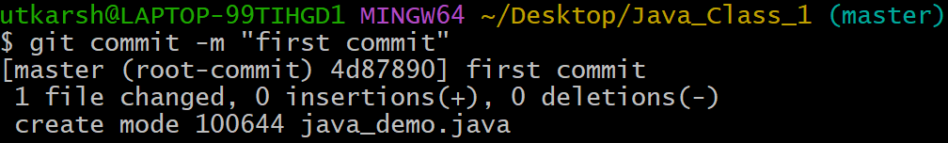

1. git status : current state of your git working directory and staging area

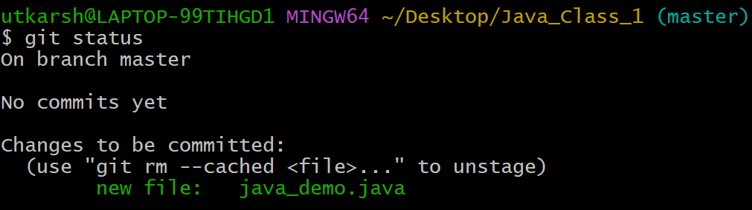

1. git branch -m main : This command renames the current branch to main



1. git log : shows the commit history of your git repo

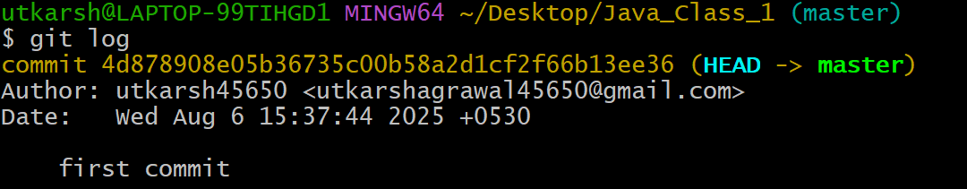

1. git remote add origin <github_link_to_push_code> : tells git where to push code



1. git push -u origin main : push your commits to the github

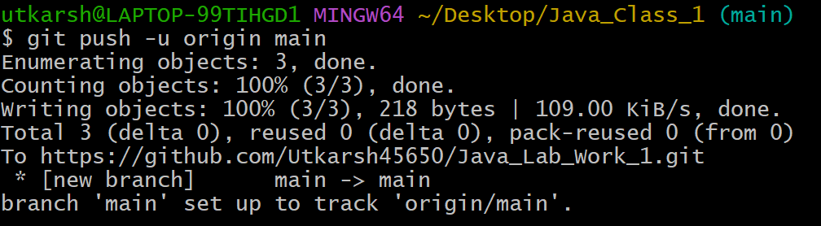

1. git branch <name> : Creates a new branch with the given name



1. git branch : Lists all branches in your local repo

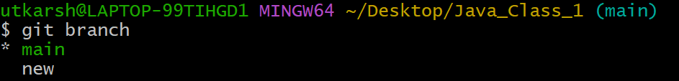

1. git switch <name> : Switches to an existing branch
2. git checkout -b <name> : Creates and switches to a new branch



1. git checkout –orphan <name> : This command creates a new branch with no commit history — it starts a completely fresh branch, as if you're starting a brand-new repository.



1. git checkout -f <branch-name> : This command is used to forcefully switch to another branch, even if it would normally be blocked due to uncommitted changes or untracked files.

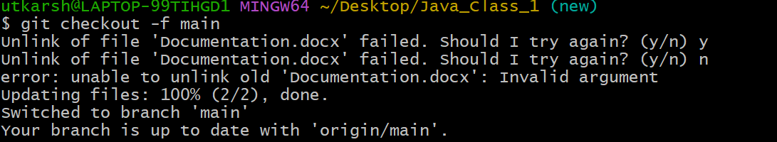

1. git branch -a : This command lists all branches, including:

Local branches (on your machine)

Remote branches (like from GitHub)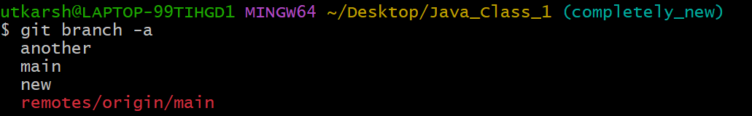

1. git branch -d <name> : Deletes the branch locally (safe delete)



1. git push origin –delete <name> : This command deletes a remote branch from a remote repository like GitHub.

